Title: **Number Conversion, Timers and Counters** Test: 4

Course: Introduction to Automation Unit: Introduction to PLC CLO: 4

Name ____________________________ Grade ______ Date ______________

**Objectives**

1. Student shall calculate the correct number conversion base on a number from a different number base system.
2. Student shall draw the output of an instruction given its input(s).

**Assessment**

Students shall demonstrate a comprehension of the objectives listed above by scoring a minimum of 75% on this Test. Grading shall be based on the answer key.

**Instructions**

Convert the following octal numbers to their decimal equivalents.

1. 348 ____10
2. 108 ____10
3. 518 ____10
4. 78 ____10
5. 1218 ____10
6. 178 ____10
7. 738 ____10
8. 118 ____10
9. 1108 ____10
10. 2018 ____10

**Instructions**

Convert the following decimal numbers to their octal equivalents.

1. 3510 ____8
2. 1810 ____8
3. 5310 ____8
4. 710 ____8
5. 12110 ____8
6. 1810 ____8
7. 8810 ____8
8. 1210 ____8
9. 11110 ____8
10. 11210 ____8

Fill in the appropriate letter based on the graphic below.



1. Word _____
2. Nibble _____
3. Byte _____
4. Bit _____
5. A QWORD can store larger numbers than a DWORD.
   1. True
   2. False
6. How does a signed integer one word in length indicate that it is a negative number?
   1. Bit 0 is set to a 1
   2. Bit 8 is set to a 1
   3. The MSB is true
   4. None of the above
7. The least significant bit, or LSB is represented by?
   1. Bit 1
   2. Bit 0
   3. Bit 15
8. Does this online view of a rung have logical continuity? Why or why not?

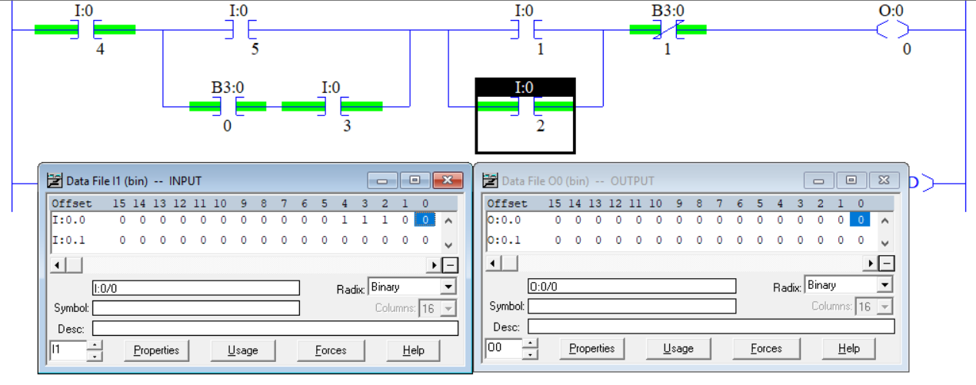

Select the best answer to each multiple-choice question below.

1. A CTU would be used to?
   1. Timing a specific set of contacts
   2. Be a Clock timer unit
   3. Counting up to a certain Preset
   4. Counting down to a certain Preset
2. A CTD would be used to?
3. Each rung continuity true transition, decrements an integer by one
4. Subtract two numbers until they equal each other
5. Counting up to a certain Preset then setting the done bit
6. Is used to test for a 0 and sets the Accum value
7. Fill in the state of each timer bit (0 or 1).

|  |  |
| --- | --- |
|  | EN _____  TT _____  DN _____ |

1. Fill in the state of each timer bit (0 or 1).

|  |  |
| --- | --- |
|  | EN _____  TT _____  DN _____ |

1. What describes an Integer?
2. A whole number
3. Any number that doesn’t have a fraction.
4. Is negative or positive
5. All the above
6. The ladder logic below is offline (i.e. there will be no green highlighting). The input table below is the current state of all the inputs. What is the value of O:0/4?

